LAB Logbook

Lab 1

Lab 2

Test Accuracy : 0.966

Lab 3

ACCURACY = 0.89

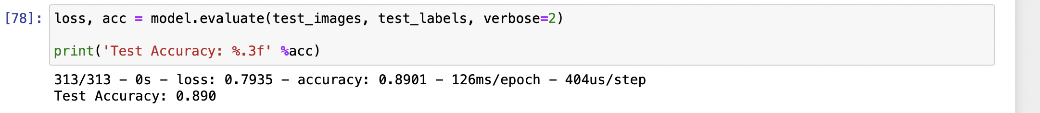

Lab 4

Lab 5

Lab 6

Lab 7

Lab 8

Lab 9

Lab 10

Lab 11

Lab 12